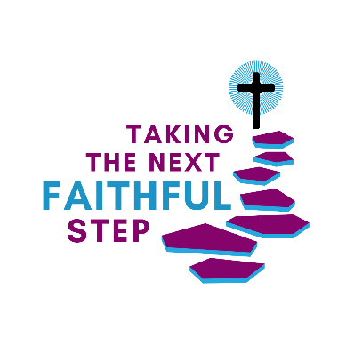
Taking the Next Faithful Step
Annual Giving Campaign for 2024
St. Mary Magdalene Episcopal Church
Our/my gift is $ per [week | month | year] for an annual total of $
(circle one)
Name(s):
Address:
City: State: Zip:
Telephone(s):
E-mail:
Signature: Date:
I do not wish to receive pledge envelopes. I would like information about
(you will automatically receive pledge envelopes unless Appreciated Stock Transfers.
you check the box.)
I would like information about using I would like information about paying
electronic transfer to pay my pledge. my pledge with a credit card.
I choose to fulfill my financial pledge to St. Mary Magdalene electronically. I place this card in the offering plate as a way of participating in our worshiping community.
If you would like more information about electronic giving, or other options
for fulfilling your financial pledge, please contact rev.carolyne@stmarymagdalene-md.org

